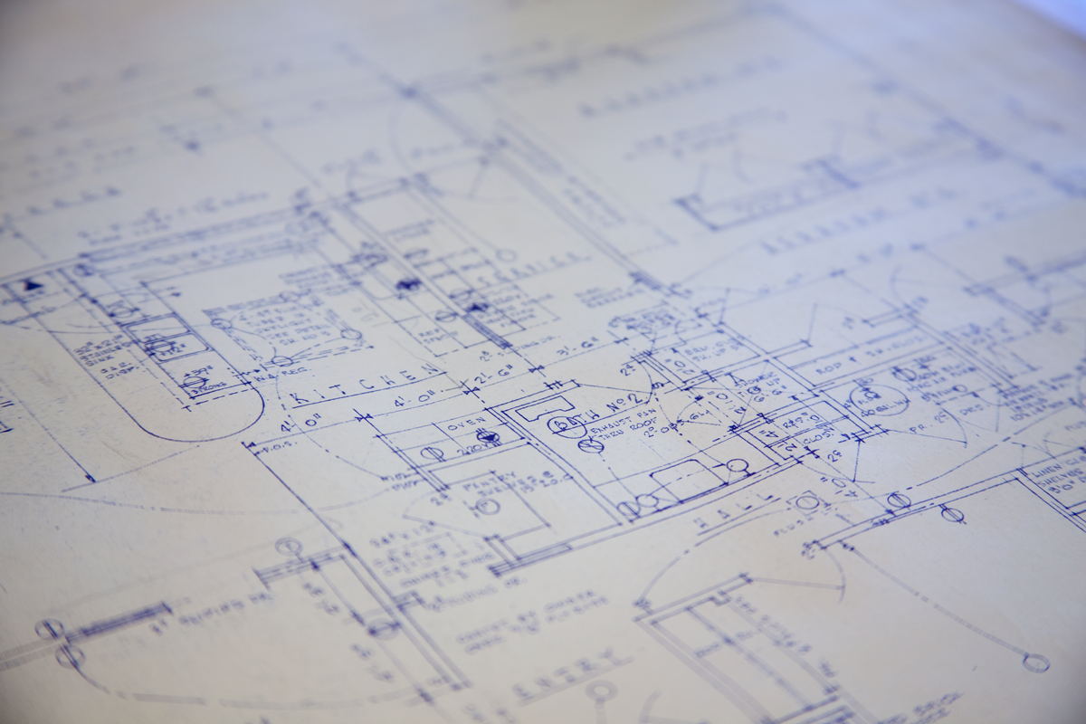
A Strategic Plan for the University of Oregon’s Portland
Library and Learning Commons

Emily Cable
Helen Harris
Amanda Meeks
Alyssa Vincent
Meggie Wright

Team Ducklings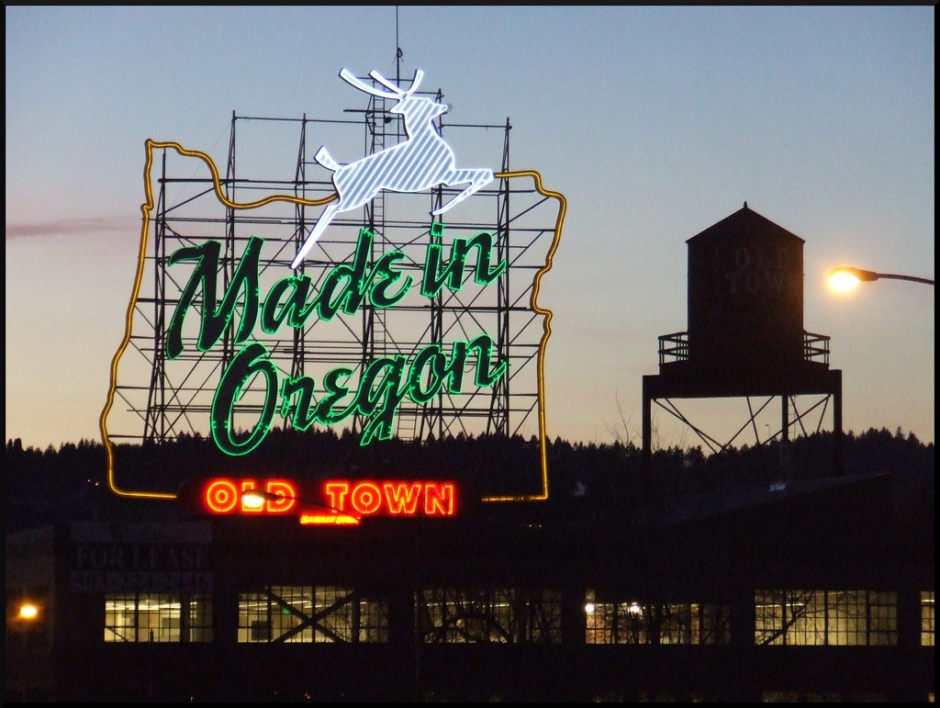

Table of Contents
Executive Summary 4
Organizational Profile 5
Overview 5
Guiding Values 6
Mission 6
Preparation/Planning 6
Library Management Team 6
Planning Factors 7
Current Reality 7
Environmental Scan 7
SWOT Analysis 9
Organizational Performance 9
Gap Analysis 11
New Priorities 12
Strategic Profile 12
Future Vision 12
Strategic Initiatives 12
Action Plan 14
STRATEGIC INITIATIVE PLAN #2: 17
Objective #1 Methods: 17
Objective #2 Methods: 18
Timeline 20
Performance Management 21
Contingencies 22
Budget 23
Concluding Remarks 24
References 25
Appendix: Summary Report of Team Project Activities 26
Team Ducklings Narrative 27
Meeting Minutes 29

Executive Summary
The University of Oregon Portland Library and Learning Commons is a branch library with a collection focused on the unique needs of its patrons. While the physical collection focuses on architecture, art and art history, and strategic communication, the library is a point of access for the rich collections of the UO Libraries in Eugene and the thirty-six Summit member libraries in Oregon, Washington, and Idaho. The planning team has decided to create the branch’s first-ever strategic plan to respond to the branch’s recent organizational changes and the unique needs of the branch, apart from the system-wide plan. Each initiative in the branch-specific plan was derived from a system-wide goal, and shows how our branch can uphold the mission and guiding values of the University of Oregon Libraries.
Our initiatives include responding to the changing information needs unique to our user-community and supporting instruction that fosters academic success. For each initiative, we have focused on two objectives to show how our library plans to work in a measurable and practical way toward achieving the goals in the system-wide plan that we feel best represent the needs of our unique community. The first initiative’s objectives include implementing a purchase-on-demand interlibrary loan (POD ILL) collection development model and furthering the development of an architectural materials resource collection. The second initiative’s objectives focus on the creation of a required 1-credit information literacy course for all incoming students and the development of new outreach and marketing methods to inform patrons of the library’s many services. Without this branch-specific plan, our library will fail to examine the specific ways we can implement improvements. To excel, we must remain relevant to our patrons and their needs and make them better aware of the services we offer. To achieve this, we need a constant measure and evaluation of our progress towards our goals and objectives on both a branch and system-wide level. This strategic plan represents our efforts to bring these positive changes to fruition.

Organizational Profile

Overview
The University of Oregon Library system has a strong history of strategic planning, but the individual libraries have not traditionally developed their own strategic plans to complement the larger system-wide plan. In addition to the main University of Oregon library in Eugene (Knight Library) there are six additional branches: Architecture and Allied Arts Library, UO Portland Library and Learning Commons, Law Library, Mathematics Library, Oregon Institute of Marine Biology Library, and the Science Library. The librarians and staff at each library have sought to find the areas of the system-wide strategic plan that best fit their library, but why not take the opportunity to focus on planning for the unique needs of each user community that the libraries serve?
The UO Portland Library and Learning Commons is in a position to begin crafting their own strategic plan due to a recent organizational change. For the past year and a half, Portland Library and Learning Commons has only had one full-time librarian/associate professor. Over the summer, another part-time librarian/adjunct faculty member was hired. This provided us with an opportunity to reexamine the branch’s goals and objectives in a more targeted way. As we engaged in the strategic planning process, it was decided that the current part-time librarian will become full-time in order to accomplish our objectives. The full-time librarian has done an excellent job of identifying the branch’s strengths, and it is from her analysis that we begin to formulate the foundation of the UO Portland Library and Learning Commons strategic plan.
This strategic plan, written in November 2011, will be regularly revisited by the planning team and will reflect the goals and initiatives planned for a time period of 18 months. At the end of 18 months, an elected planning team will create a new or revised strategic plan.

The Organization
Located at 70 NW Couch Street in Portland, Oregon, the UO Portland Library and Learning Commons provides support for instructional technology for the White Stag Block. The university’s Portland presence gives students and professionals hands-on opportunities in subjects such as journalism, architecture, digital arts, product design, law, and other continuing education courses. Services within the building include an Output Room and the Digital Fusion Lab. Within the Library and Learning Commons, we provide several workstations with a full suite of productivity and design software and offer access to a group study room and classroom.
We integrate learning spaces, collections, reference and consulting services, and technology access to support all of the UO's academic, research, and community outreach programs in Portland.

The Library and Learning Commons fosters collaboration and community among students and faculty, with our main campus in Eugene, and with our 36 partner institutions in the Orbis Cascade Alliance. We have strong and growing collections in architecture, art and art history, and strategic communication. Our staff is cross-trained to provide assistance with research and reference questions, instructional technology support, and access and borrowing. In addition to our on-site collections and services, we assist students and faculty in accessing the rich collections of the UO Libraries in Eugene, and of the thirty-six Summit member libraries. Items from all of these libraries can be picked up at our location.

Guiding Values
The University of Oregon is guided by values of scholarship, research, and the transfer of knowledge in the liberal arts, the natural and social sciences, and the professions. We are dedicated to fostering the next generation of creators and innovators as well as establishing a framework for lifelong learning that leads to productive careers and to the enduring joy of inquiry.

Mission
The University of Oregon Libraries enrich the student learning experience, encourage exploration and research at all levels, and contribute to advancements in access to scholarly resources. As a branch of the University of Oregon Libraries, the UO Portland Library and Learning Commons seeks to more actively engage our unique user community and identify their needs through well-curated collections and specialized instruction.

Preparation/Planning

Library Management Team

Emily Cable, Instruction Consultant
Helen Harris, Outreach Coordinator
Amanda Meeks, Special Collections Coordinator
Alyssa Vincent, Collection Development Advisor
Meggie Wright, Administrative Specialist

Auxiliary Consultant

Karen Munro, Head Librarian of Portland Library and Learning Commons

Planning Factors

Since the Portland Library and Learning Commons is part of a larger library system, it is important that our strategic plan not stray too far from the goals outlined in the system-wide plan. Any change regarding collection development policies or instruction will likely need to be approved by the University of Oregon Knight Library staff. In anticipation of that, we will schedule a series of meetings to occur in Eugene at the Knight Library that will address the more specific aspects of our strategic plan. As there are two groups of staff in different locations to coordinate (Portland and Eugene), this will surely complicate the planning process. That being said, we have confidence in the importance of developing this library’s own strategic plan, and we feel that the other branches within this library system will benefit from seeing us go through the process.

Current Reality

Environmental Scan

The U O Portland Library and Learning Commons serves more than just the community of students and staff members on site. We have made it a priority to make our resources accessible to the community through the Oregon Card Program, which allows any state resident to benefit from the library’s services. Because we are serving more than the small community of students and faculty, our strategic plan must also identify the needs of this broader community. Library services should reflect the needs of planners, architects, and professionals in Oregon as well as the general public. We must also anticipate the needs of the potential for growth at the UO Portland Learning Commons campus. This includes new academic degree and continuing education programs. The general Annual Report for University of Oregon Libraries showed a downward trend in library usage. Because these numbers apply to all branches in the system, our strategic plan aims to help us understand our place within the system, increase usage among our own patrons, and better meet their needs.

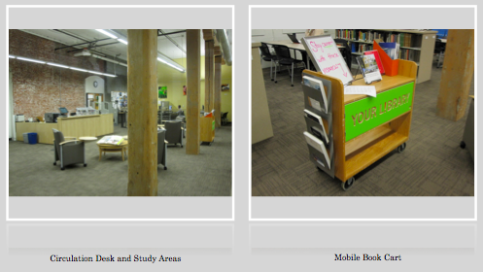
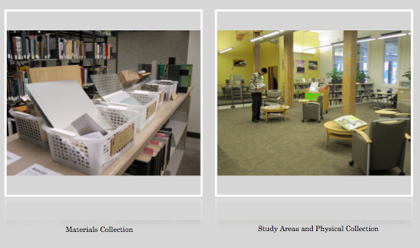

SWOT Analysis

STRENGTHS  - Strong collection of discipline-specific materials.  - Excellent technology tools and support.  - Flexible physical space to meet the needs of users.  - System-wide increase in usage of online resources.  - New space for materials library. | WEAKNESSES  - Need for a culture of assessment that involves all library staff members and student workers.  - Need for instruction in information literacy.  - Lack of awareness of library services among patrons.  - System-wide drop in physical use and visitation, according to the annual report.
OPPORTUNITIES  - Increased budget for technology.  - Recently-hired staff with flexible job responsibilities.  - Paraprofessional staff members are students in an MLS program. | THREATS  - Coordination required with staff in - Eugene for any changes in policy.  - Physical location in an urban center with high crime rate.  - State budget cuts and financial uncertainty.

Organizational Performance

In the 2009-2010 Annual Report, the UO Libraries Assessment Team conducted a Return on Investment (ROI) analysis in conjunction with several academic libraries. From this analysis, we were able to determine the allocation of resources and put a dollar amount on the value of each service. At the end of the 18-month period, the UO Portland Library and Learning Commons will conduct a branch-specific assessment of library services, including circulation and reference statistics. Below, we have included the ROI analysis from the 2009-2010 University of Oregon Libraries Strategic Plan.

Resource |  | Cost of Investment | Value
Book and Audio/Visual Checkouts | Total Checkouts = 340,249  Includes general collection, reserves, Summit and Interlibrary  Loan checkouts and a calculated use of in-house items. | $26.12 per use. Based on 50% of  the average Amazon.com unit order cost for scholarly material. The assumption is that access to a volume through borrowing it from the library is worth a user 50% of what it would cost to purchase the book. | Total checkouts by cost of investment = 340,249 x $26.12  $8,887,304
Electronic Resources | Total use of electronic resources =  2,531,221  Includes full-text article downloads from licensed resources; ILL articles borrowed; use of electronic reserves and E-book use. | $15.75 per full text article retrieved online or borrowed. This is 50% of the cost of obtaining articles on a Pay-Per-View model from Science  Direct. | Total use of electronic resources = 2,531,221 x $15.75  $39,866,730
Reference Service | Number of reference questions answered = 55,078 | $15 per reference transaction, from the Massachusetts Library Association library value calculator. | Reference service = 55,078 x $15.00  $826,170
Research Consultations with Faculty and Students | Number of research consultations with faculty and students = 1,535 | Average time of 90 minutes per consultation and a research service published fee rate of $60/hour. | Research and consulting service =1,535 x 1.5 x $60.00  $138,150
Distribution of UO-created and/or unique content to the world | The number of queries/items viewed in Scholars’ Bank; Local Government Documents Archive; University Archives & Electronic Records; UO Channel; 25 other digital collections; and e-Asia. = 335,185 | Assumes that half the commercial pay-per-view charge ($15.75) describes the value of disseminating a UO-authored document. | Distribution of local  content = 335,185 x $15.75  $5,279,164
Equipment borrowed or set up in campus classrooms | Number of deliveries to, and pickups from, classrooms = 7,221 | $50 per equipment loan and classroom setup. The rate for a common equipment loan (laptop and projector) is $35.00 and the rate for delivery and setup of the equipment to a classroom is $15.00. | Equipment loan, delivery, and setup in classrooms = 7,221 x $50.00  $361,050
Return on Investment | UO Libraries’ expenditures for FY 2010, from all sources: $19,580,401 | The total calculated value of the use of library collections = $55,358,568. Divided by the expenditures equals the return on investment. | Return on investment:  2.8 : 1
(Slight-Gibney, N., Willey, L., Munro, K., Fowler, D.C., & Thompson, M, 2010).

Gap Analysis
As we have previously identified, overall usage of our physical collections and the library as a space is down on a system-wide level. While we have attempted to include the general public at large by implementing the Oregon Card program, we have not done as much work as we could to identify and anticipate the user needs of this community. However, thanks to a commitment to technology spending, the usage of our full-text electronic serials collection and visits to the library website have all increased by a sizable percentage. Informed by this data and with a new focus on branch-level planning and assessment, we will recommit ourselves to stimulating the usage of our physical collections and space and engaging our community-wide patrons. Various assessment tools such as reference statistics, circulation statistics, and door counts will assist us in measuring our progress in these goals.

New Priorities

Strategic Profile

In the University of Oregon Library’s 2009-2010 Annual Report, the UO Libraries Assessment Team identified six goals to guide the next phase of growth for the library systems. From these six goals, the UO Portland Library and Learning Commons chose to focus on two goals that would most benefit our patrons. The academic library of the future is one that not only prepares its patrons to engage in thoughtful research for the rest of their lives, but that offers customized services that allow for greater collaboration between staff and patrons. These two goals align well with those strategic thrusts of collaboration and instruction. By focusing on these two goals over the next 18 months and beyond, we hope to transition our library from its traditional academic role into an information commons that is fully integrated into the design community and the information-seeking public at large.

Future Vision
We have already shown a strong commitment to technology, and data shows that our patrons appreciate that. We will strive to remain on the cutting edge by continuing to engage with emerging technologies. Since we make innovation a priority at the UO Portland Library and Learning Commons, we will also use technology to support our goals and initiatives. For some libraries, technology can be an intimidating tool that they feel forced to use. We hope to avoid this fate by integrating it into our everyday practice and into our larger institutional vision. We rise to the challenge of evolving alongside new advances in technology and feel it can strengthen our library. Our mission statement will be unchanged by this embrace of technology, as technology is a means to achieving our goals in engaging our users and cultivating specialized collections.

Strategic Initiatives
The UO Portland Library and Learning Commons has a strong collection that is uniquely tailored to our specific user community. We are confident in our collection, but several academic libraries have implemented a purchase-on-demand interlibrary loan (POD ILL) model for collection development. According to our research, patron-initiated collections have a higher circulation rate than strictly librarian-developed collections, so we feel that this model will be better for our budget and also for our users. We will monitor the progress of the pilot over the course of a year. Along similar lines of enhancing our collections, the UO Portland Library and Learning Commons has a small physical collection that consists of eight storage bins of architecture materials such as different types of tile and wood. By further developing this collection, we can provide materials our patrons need. We will actively seek donations for the materials library over the next year and will simultaneously work on converting the spare classroom into a repository for the materials collection.
The UO Portland Library and Learning Commons also seeks to develop and implement new ways to foster academic success in students and support the faculty and staff of the UO Portland campus. Currently, the library provides reference and research services, instructional technology support, and access and borrowing. Currently, the library provides instruction on the use of databases and the library catalog to classes and groups by appointment. We hope to increase instruction at the library through a 1-credit required class for new students. This will help market the library’s services, foster students’ academic success through better research skills, and promote information literacy. The library also seeks to market library services by taking advantage of opportunities for outreach in the UO Portland community. As for current outreach efforts, the library currently stocks a cart of new and relevant books and visits studio spaces used by UO Portland students. We hope to find new ways of bringing the library’s services to students, faculty, and staff to make them aware of what the library has to offer them.

STRATEGIC INITIATIVE #1:
Respond to the changing information needs unique to our user-community.

Objective #1:
Further develop architectural materials resource collection and develop a resource center within the library. Collecting and curating materials will be an ongoing process for 18 months. Transitioning the study room space into a resource center will be occur simultaneously over the course of the first six months.

Objective #2:
Implement a POD ILL collection development model allowing patrons a larger say in the direction of the collection. At the end of the 18-month long pilot, we will look at circulation reports to evaluate its success or failure.

STRATEGIC INITIATIVE #2:
Support instruction that fosters academic success.

Objective #1:
Develop and implement a required 1-credit course for all incoming students to familiarize them with the library and its resources.

Objective #2:
Develop new strategies for outreach and market library services to students, faculty, and staff members. This will include providing on-site reference services to students in studio spaces and creating a welcome packet for distribution to incoming students, faculty, and staff members.

Action Plan
STRATEGIC INITIATIVE PLAN #1:
Responding to the changing information needs unique to our user-community means involving our user-community on a more fundamental level through developing our collections while taking their input into consideration and appropriating physical space accordingly.

Objective #1 Methods:
The head librarian will continue to work with the Portland Student Action Council (PSAC) in order to further develop the architectural materials resource collection and develop a resource center within the library. In the primary stages this endeavor will include regular meetings with the PSAC, fostering relationships with vendors and donors, and collaboratively developing a collection policy (i.e. what materials should be collected and what should not). Collecting, curating, and cataloging materials will be an ongoing process for 18 months and will involve help from all staff and student workers, but will continue to grow and develop beyond that time period. Consequently, the current space allotted for the resource collection will no longer be suitable as the collection grows. The space, which is currently the “group study room,” will be transformed into the Architectural Materials Resource Room over the course of the first six months of this initiative. The librarians will need to acquire appropriate shelving, a work table, signage and processing materials for the expanding resource collection. The computer station will also need to be relocated.

Budgeting:
Currently there is no budget for this project and all of the current collection consists of donations. We would stick to this model for this year and possibly build a budget for the acquisitions to fill needs and gaps in the collection after one year. The cost of transforming the study room into the Architectural Materials Resource Room will include specialized shelving units to fit the room, a work table, signage, bins and containers for materials in the collection, and processing materials such as labels. Allocating approximately $2,000 for this transformation process would cover these initial costs.

Measurable outcomes:
We will be keeping track of collection use through observation, record keeping, and student feedback. However, once a circulation system is in place for this unique collection, statistics can be measured more formally.

Objective #2 Methods:
One aspect of the recently hired librarian’s job is to oversee the library’s circulation and access department. While she was hired to be part-time, we feel that it is necessary for her to be full-time in order for our objectives to reach fruition. Upon her full-time employment, we will look to her to play an integral part in implementing the purchase-on-demand interlibrary loan system. Given that the head librarian controls the “general” collection budget that we will allocate for this objective, we expect that she will assist in this as well, but in a lesser capacity. This shift in collection development policies will be brought up in a series of meetings held with the Knight Library staff in Eugene. Our hope is that the University of Oregon libraries will adopt this model of collection development system-wide should our model prove to be successful. Interestingly, the Orbis Cascade Alliance launched a demand-driven acquisition e-book pilot last year. This shows that at a consortium level, there is openness to moving toward this model of collection development. Based on the literature we have read, our idea of success would be an increase in circulation statistics among the patron-selected titles and a decrease in reliance on interlibrary loan (Tyler, Xu, Melvin, Epp, & Kreps, 2010). Each interlibrary loan request costs the library $30. While that may not seem like a lot of money, it certainly adds up over time and over many requests. However, the library staff in Portland cannot do this alone, as all ILL requests are routed through Knight Library in Eugene. With the help of the interlibrary loan staff in Eugene, all ILL requests made by Portland Library and Learning Commons patrons will be forwarded to the librarians in Portland. Upon receipt, the librarians will consult a list of criteria before going through with a rush order of the manuscript. The patron will receive an e-mail informing them that the book is not being borrowed, but rather ordered by the Portland Library and Learning Commons, and that they will have it shortly. The criteria for ordering monographs are below:
- Under $200
- Preference given to titles within University of Oregon’s academic specialties
(architecture, product design, journalism, digital arts)
- No textbooks.
- Exceptions can be made for judgment calls

Budgeting:
Currently, the acquisitions budget is divided into architecture, digital arts, product design, and journalism, all of which are controlled by subject specialists in Eugene. The head librarian at Portland Library and Learning Commons has control over a “general” fund, which amounts to $2,000. This is the fund that we will put towards the POD ILL program. Also, it is necessary to supplement the part-time librarian’s salary as she transitions to full time. A portion of this increased salary will come from revenue generated by the tuition for the information literacy course that is being implemented, and $5,000 will be allocated to the library staffing fund to supplement her salary.

Measureable outcomes:
We expect that we will see increased use of the patron-selected titles versus the librarian-selected titles, and we will be able to monitor this using the “Management Reports” module in Millennium ILS.

STRATEGIC INITIATIVE PLAN #2:
The library’s goal of improving the academic performance of students hinges on the library’s ability to engage as many students, faculty, and staff members as possible. The Learning Commons hopes to increase the number of library users by implementing a required 1-credit class on information literacy and through developing new methods for outreach and marketing of the library’s services.

Objective #1 Methods:
Studies have shown a positive correlative relationship between library literacy courses and higher final GPA. The library plans on implementing a 1-credit course that would be required for all incoming students at both the undergraduate and graduate levels. The course can be waived if the student has completed a comparable literacy course at another institution. The course would focus on what services the library offers and how to use them. Also, an information literacy thread will be woven throughout the course, showing students not only how to find information but also how to assess and evaluate the information found. A survey will be distributed at the end of the course to gain student feedback. The survey will be used as part of an ongoing assessment of student satisfaction with the course. The content of the course will be designed during the first six months and implemented the following academic year.

Budgeting:
In addition to greater circulation and access duties, half of the recently-hired librarian’s job will be to undertake the planning and teaching of the course. $5,000 has already been allocated to the library staff budget to cover her increased circulation and access departmental responsibility, and the remaining portion of her full-time salary will be paid from revenue brought in by tuition paid for the course.

Measurable Outcomes:
Post-course student surveys will be one measure of the success of the course. The effect of this course can be assessed by a concentrated study of scholarly citation use. For this to be effective, during the months the course programming is under design, a sample group of students’ scholarly citation rate should be collected so it can be compared to scholarly citation use after the course. These student’s pre- and post-course grades can be compared and possibly used as another factor to assess the course’s impact.

Objective #2 Methods:
The library’s plan to develop new strategies for outreach and marketing has the goal of increasing the number of students, faculty, and staff that use the library’s services. The library hopes to implement a plan for outreach that includes developing a welcome packet for new students, faculty and staff and by providing on-site reference services in studio spaces.

1. Welcome Packet
The welcome packet will include materials that provide information about the library’s hours, services, materials, staff members, and upcoming library programming. It will also introduce the library’s brand and give students and faculty a visual familiarity with the library’s logo and graphic representation. The welcome packet will have basic guides to accessing the library’s electronic resources, tips and tricks for good search techniques, and a map of the library’s physical space. The design of the welcome packet will be consistent with the University of Oregon Library’s existing materials and will be developed for distribution to students and faculty in August 2012. Initially, the packet will be distributed to each enrolled student and current faculty and staff member at the University of Oregon’s Portland branch campus. Subsequently, the packet will only be distributed to new students and faculty members. Library staff members will administer a survey of incoming students and faculty during the required 1-credit class, which will contain questions about the effectiveness of the welcome packet.

2. On-site Reference Services
The Learning Commons already uses a mobile book cart that highlights relevant and new library materials to engage the students in studio spaces. This plan calls for the expansion of this service by adding on-site reference services to be performed by the library staff member responsible for the mobile book cart. The studio spaces already have access to wireless internet, and the staff member who mans the book cart will use one of the library’s laptops to set up a station for providing reference services to students using the studio. This service will provide reference services to students who otherwise might not seek the help of a librarian. The staff member performing on-site reference services will keep a record of the number of reference questions answered in the studio spaces to determine the effectiveness of the new service.

Budgeting:
1. Welcome Packet
The welcome packet will be designed by a graphic design student for class credit, so the only cost associated with the welcome packet will be compensation for staff hours spent on the development of the materials and the cost of printing and distributing the packet. The estimated cost of the printed pocket folder with welcome packet documents is $1.25 per packet. The total amount budgeted for the development and printing of 1,000 packets is $2,000. The team plans to fund the printing and distribution of the welcome packet with general funds from the University of Oregon Library’s Outreach Budget and will plan to expand outreach services as more funds become available.

2. On-site Reference Services
Since a library staff member would already be manning the mobile book cart, the only expense for this new service will be the cost of the reference training session. The training would be a one-time training conducted by the library director. The library will budget $50.00 per staff member for this expense and would limit the number of staff trained in reference services to 5 people per fiscal year for a total expense of $250.00.

Measurable Outcomes:
1. Welcome Packet
We expect that the welcome packet will increase the door count and number of visitors to the website of the UO Portland Library and Learning Commons. This will be measured by comparing the September 2010 door count with September 2011 door count and by analyzing web traffic to the home page. We will also administer a voluntary survey to first-time library visitors and first-time visitors to the library website asking how they found out about the library and which specific service(s) they came for.

2. On-site Reference Services
We expect to see an increased number of in-person reference questions, due to the addition of on-site reference services. We will measure the number of reference questions asked by analyzing the statistics kept by staff members conducting reference services.

Timeline

January 2012 | - Preliminary meeting with PSAC to assess the current materials collection, schedule monthly meetings to check-in.  - Meet with ILL staff in Eugene to discuss communication between the branches for the POD ILL program.  - Draft outreach survey for first-time library users.
February 2012 | - New full-time librarian meets with library staff in Eugene to begin developing information literacy course curriculum.  - Start envisioning the design of the welcome packet.  - Begin transitioning the study room to the materials library.  - POD ILL pilot begins.
March 2012 | - Interview graphic design students for welcome packet job.  - Reference training for student workers begins.  - Have a draft curriculum of information literacy course in place.  - Procure shelving and storage for materials library.
April 2012-July 2012 | - Monthly PSAC meetings continue, as does the transition of the study room.  - POD ILL budget is carefully monitored, and monthly circulation reports are generated.  - Develop post-course survey for information literacy course.  - On-site reference services begin in April, with a monthly review of reference statistics.  - Relocate computer station so that it is out of the materials library. Continuing furnishing that space.
August 2012 | - Information Literacy course officially begins.  - Welcome packet is distributed.  - Materials library transition is completed.
September 2012-February 2013 | - Statistic reports continue to be generated on schedule.  - Donations for materials collection continue, post circulation sign-in sheets in materials library.
March 2013-June 2013 | - POD ILL budget continues to be carefully monitored.
July 2013 | - Evaluation of information literacy course begins with post-course student surveys.  - Donations for materials collection stop, evaluation of current collection begins.  - Evaluation of POD ILL pilot commences.  - Outreach program is assessed.

Performance Management
Initiative #1:
Since the two objectives that fall under our first strategic initiative will be implemented at the same time, we clearly feel that they have a strong synergy. Both initiatives speak to the library’s desire to better anticipate the needs of our users and deliver on those needs. However, they are more complementary to one another than entirely identical. The re-energizing of the material resource collection will not have as much input from the entire population of patrons, but will focus on PSAC’s input and representation of the student population. The shift in our collection development policy, however, will involve all patrons of the library. Clearly, a patron-initiated collection development policy will allow greater interaction between the staff, faculty, and patrons. Since we believe that our print collection has a strong foundation, we look forward to the new insight that patron suggestions will bring to both the material resource collection as well as the POD collection. We will utilize the Management Reports module in Millennium ILS to create circulation statistic reports and monitor usage of the material resource collection through a sign in sheet and circulation stats (once the collection is able to circulate).

Initiative #2:
The second strategic initiative focuses not only on making people aware of library services but also providing those patrons with the skills they need to use the library effectively. The two objectives under this initiative complement each other and move us toward fulfilling the library’s goal of fostering academic success in its patrons. The 1-credit course will teach students how to use the library more successfully, and the outreach projects will work as a constant reminder of what the library has to offer. These objectives aim to bring a better-informed patron base into the library in order to fully utilize the services and programs offered. These new services will go into effect in August 2012 and will be monitored by the surveys administered to students and faculty during the 1-credit information literacy course and by responses to the voluntary surveys administered to first-time visitors to the library and the library’s homepage. The statistics gathered by the staff member conducting the on-site reference services will also inform the library planning team on the effectiveness of this new service. Based on feedback from these surveys and statistics, adjustments can be made to the course content as well as the welcome information packet and on-site reference services.

Contingencies
Initiative #1, Objective #1:
The issues that may most readily present themselves in the implementation of this objective are that of staffing time and our purchasing budget. Both of these issues can be addressed with the same remedy. If the two librarians are unable to handle the volume of requests, or if they learn that the budget is being spent too quickly, then we will increase the number of requests made for a specific book to two. So, rather than buy a book that has been requested by one person, the library staff would hold off on purchasing the book until an ILL request has come through twice.

Initiative #1, Objective #2:
If the material resource collection is unable to allocate proper funds for the development of the storage space and room (through the purchasing of shelves, storage containers, signage, and processing materials), efforts will be made to rearrange the current organization wherein the collection lives on top of the shelves of print materials in the basement. The collection development would not suffer in this case and the material resource collection could be housed in a more suitable space at a later date.

Initiative #2, Objective #1:
If unable to implement the full 1-credit course right away due to funding or other logistical limitations, aspects of the course can be incorporated into a less extensive instructor/librarian collaboration program. The librarian can take content intended for the course and work with faculty to provide instruction during class time in conjunction with specific assignments.

Initiative #2, Objective #2:
If, for financial reasons due to printing costs, the welcome packet cannot be distributed to each incoming student, faculty and staff member, the packets will be made available in common areas around the campus, advisors’ offices, to instructors for distribution to classes that require a research component, and in the library itself. A file containing PDF versions of the documents in the welcome packet will be sent to each student’s university email address and will be available for download on the library’s homepage. Although this limits the exposure the welcome packet would bring to the library, it would still be worth the cost of developing and designing the welcome packet.
If, after the initial trial of the on-site reference services in student studio spaces proves unsuccessful (i.e. too few reference questions asked to warrant the training of staff), the mobile book cart will have a sign and fliers with information about the various ways to access reference services, including information on chat reference and the hours of the library’s reference desk.

Budget
Below are the University of Oregon Portland Library and Learning Commons’ budget and expenditures for fiscal year 2009-2010. The library may see an increase in the budget for fiscal year 2011-12 due to the tuition from the information literacy course, the total amount of which will be determined by the UO registrar. This money will be used to supplement the salary of the new full-time librarian and provide funding for course materials for the mandatory one-credit information literacy course.

Budget | FY 2009-2010
General funds | $643,134
Income - fees, printing, etc. | $34,501
Total budget | $677,635

Expenditures | FY 2009-2010
Staff | $274,287
Collection purchases | $23,195
E-resources | $3,733
Technology | $16,020
Supplies | $31,198
Additional expenses | $123,415
Total expenditures | $471,848

Below are the projected expenditures for carrying out the UO Portland Library strategic plan.
Strategic plan budget | Expected costs
Shelving units | $355
Work table | $400
Signage | $100
Bins/containers | $355
Processing materials | $175
Librarian salary increase | $5,000
Purchase on demand ILL | $2,000
Welcome packets (1,000 at $1.25/packet) | $1,250
Staff time for packet creation | $750
Staff reference training | $250
Total | $10,635

Concluding Remarks
Without a branch-specific strategic plan, the University of Oregon Portland Library and Learning Commons will fail to prosper as a library. Through implementation of this strategic plan, the library is positioned to better cater to its distinctive patron base by evaluating and enhancing current services and offering new opportunities. Through our acknowledgement that this will be a collaborative effort between staff in Portland and Eugene, we have ensured that all who are involved in enacting this plan are aware of what lies ahead and are able to undertake the challenges. As this is the first time that a branch has made their own strategic plan, we will thoroughly document the process and anticipate issues as best we can. We are excited for this next strategic phase for the University of Oregon Portland Library and Learning Commons and feel that it will be its best phase yet.

References

Hallmark, E. K. & Schwartz, L. (2007). Developing a long range and outreach plan for your academic library: The need for a marketing outreach plan. College Research Library News, 68(2), 92-95.

Booth, H.A. & O’Brien, K. (2011). Demand-driven cooperative collection development: Three case studies from the USA. Interlending & Document Supply, 39(3), 148-155.

Nixon, J.M., Freeman, R.S., & Ward, S.M. (2010). Patron-driven acquisitions: An introduction and literature review. Collection Management, 35(3-4), 119-124.

Slight-Gibney, N., Willey, L., Munro, K., Fowler, D.C., & Thompson, M. (2010). University of Oregon libraries annual report, FY 2009-2010. Retrieved from https://scholarsbank.uoregon.edu/xmlui/handle/1794/10924

Tyler, D.C., Xu, Y., Melvin, J.C., Epp, M., & Kreps, A.M. (2010). Just how right are the customers? An analysis of the relative performance of patron-initiated interlibrary loan monograph purchases. Collection Management, 35(3-4), 162-179.

Wagner, B. (2004). On-site reference services and outreach: Setting up shop where our patrons live. Paper presented at the Special Libraries Association National Annual Meeting, Nashville, TN. Abstract retrieved from http://www.rusq.org/2008/01/06/onsite-reference-and-instruction-services-setting-up-shop-where-our-patrons-live/

Wang, R. (2006). The lasting impact of a library credit course. portal: Libraries and the Academy, 6(1), 79–92.

Appendix: Summary Report of Team Project Activities
LI805XO: Leadership and Administration of Information Organizations
November 28th, 2011

Emily Cable
Helen Harris
Amanda Meeks
Alyssa Vincent
Meggie Wright

Team Ducklings Narrative
Throughout the strategic plan project, Team Ducklings members have not only been dedicated to producing a strong artifact that fulfills the requirements of the assignment; they have also been committed to contributing to a friendly and efficient team.

Forming – new members define the purpose and structure of the team.
- Reviewed group member leadership strengths.
- Designated roles for the group.
- Decided on methods of communication and collaboration.
- Developed rules of conduct.
- Chose organization size and type.
Forming took place at Team Ducklings’ first meeting at Rogue Brewery during the first class weekend. Group members discussed how the group should function over the course of the project. Because all group members were familiar with each other and many had worked together on previous projects, Team Ducklings did not spend long in the “forming” stage.

Storming – conflict occurs over different ideas.
- Researched chosen topic independently.
- Compiled resources into Google documents.
- Chose team name.
- Discussed options for presentation.
From the beginning of the project, Team Ducklings members believed that “storming” should be done in understanding and supportive ways. While discussions on differing ideas did occur throughout the project, the maturity of individual team members helped to resolve conflict respectfully.

Norming – close relationships develop and the team becomes cohesive.
- Divided up the project among team members for independent work.
- Communicated regularly through email and group meetings.
Throughout the project, it was clear that all team members were committed to making the team function and producing a strong final project. Team members did not hesitate to volunteer to take on remaining work.

Performing – strong team structure allows team to function as a unit.
- Built a team culture that allowed and encouraged constructive feedback.
- Held an extended meeting to complete project collaboratively.
At the team’s meeting on November 4th, group members stated that they believed that the group would produce the most cohesive product if it met in person and completed the majority of the assignment together. During this meeting, group members successfully “performed” by collaborating on the assignment through respectful and insightful dialogue from all group members.

While strong cooperation and positivity was exhibited from all members of the group, Team Ducklings meetings did not always go smoothly. The group experienced difficulty arranging meeting times that accommodated group members’ changing work schedules and multiple out-of-state vacations. On one occasion an online meeting needed to be cancelled and was never rescheduled. Thankfully, due to flexibility and understanding from all group members, the issue of availability did not inhibit the group’s ability to complete the project.

Additionally, because the members of the group were already familiar and friendly with each other, there was a tendency at group meetings to discuss subjects that were unrelated to the project. A certain amount of socializing is to be expected during group forming and for maintaining good team morale. However, mingling between Team Ducklings members got meetings off task a little too frequently. Respectful reminders to stay on topic from team leader Emily Cable were essential to keeping team meetings useful and productive.

Despite the challenges faced by Team Ducklings, the group was able to persevere in completing the strategic plan project in large part due to the understanding, maturity, flexibility, and responsibility of all members of the team. This team project set an example for how well group work can go when all members are committed to contributing to a successful team experience as well as a successful final project.

Meeting Minutes

Meeting Minutes – September 17th, 2011

Location: Rogue Brewery by Portland State University.
Members present: all group members were in attendance.

Agenda
- Decide team member roles.
- Discuss assignment – what are we doing?
- Determine team rules and norms.
- Decide on communication methods.

Business
Team rules
The group decided that it would decide things democratically. At in-person meetings, rock/paper/scissors will be used as a tiebreaker as needed.
The team discussed issues with previous group projects in hopes of avoiding conflict in the future. It was decided that strong communication was to be required of all group members. If a group member needs to miss a meeting, they are expected to inform the group as soon as possible via email. In the case that a group member is unexpectedly absent from a meeting, they will be sent a reminder via SMS messaging. If a group member misses a project deadline, they will receive an email reminder the next day and will need to make arrangements with the group to get their work completed as soon as possible.

Communication
For communicating, all group members agreed that they preferred email and Google Docs to blackboard for electronic communication. Emily Cable volunteered to create a Google group for the team to help streamline email correspondence. Meggie Wright requested that in-person and online audio meetings be held as well. The group scheduled in-person meetings for October 7th and November 4th, and agreed to hold approximately one Skype meeting per month, to be scheduled at a later date.

Assignment
The group decided that determining a library type and size was the first step in starting the strategic plan assignment. Thus, the group focused their discussion of the assignment on this topic. Emily Cable and Helen Harris both discussed their previous struggles doing projects on special libraries, despite their interest in them. Amanda Meeks and Alyssa Vincent suggested looking at the University of Oregon Portland branch library. As a small, subject specific, university library, it possesses attributes of both special and academic libraries. All group members felt this would be a good fit and agreed to discuss it further at the next meeting.

Member roles
The group had to assign two members to the roles of team leader and secretary. Meggie volunteered to be group secretary. Alyssa and Emily volunteered to be co-team leaders but later decided that Emily would fill the role of team leader.

Next Meeting
The group planned to hold a meeting on Skype soon, but did not schedule a day or time during the meeting. Through email and Google Docs, the group later scheduled to meet September 27th at 9:00pm.

Meeting Minutes – September 27th, 2011

Location: Online via Skype.
Members present: all group members were in attendance.

Agenda
- Finalize the type and size of library.
- Discuss tasks and group roles.
- Determine group deadlines to stay ahead of the project due dates.
- Start work on the strategic plan: brainstorm goals and objectives.
- Choose a team name.

Business
Finalize library type
Alyssa reported on findings on the UO Portland branch library. The branch library:
- Tries to fit into the plan of the large university institution. It does not have its own separate plan, but tries to shape the over-arching plan
to match its own needs.
- Attempts to answer the question "What does [the branch] have to offer?"
Branch plan needs to be more specific and must address limited resources.
- Develops specialized collections, or "demand driven collection development." It develops a collection specific to the needs of the branch’s users as opposed to a large subject collection.
Based on this information, the group decided to base the library for the strategic plan on the UO branch library in Portland.

Goals and objectives
The group decided to base the goals and objectives for the strategic plan project on the greater UO library plan by personalizing the plan to the specific needs of the Portland branch and its users.
Amanda Meeks suggested the goal of utilizing the library’s limited physical space. Possible objectives related this goal were discussed by the group were to rearrange physical space for increased usability and increasing the offering of online materials to free up physical space in the library.
Emily Cable suggested another goal of supporting instruction and outreach. The group suggested possible objectives for the goal, including introducing information literacy courses, increasing outreach to specific user groups, and increasing collaboration with professors/staff.

Discuss tasks
Helen Harris stated that she created a Google document and shared it with the group. The document contained the various assignment requirements so that group members could sign up to complete different sections. The group decided to discuss this again at the next group meeting.

Deadlines
The group decided that since all group members are fairly self-directed, we will continue preliminary research for the time being and determine concrete deadlines at the next meeting when we have developed a greater understanding of the project.

Choose team name
Meggie Wright suggested that since the group would be basing the library on the UO Portland branch, a UO related name might be appropriate. Amanda suggested the team name Ducklings. All group members agreed on this team name.

Next meeting
The group had already made arrangements to meet in-person when Meggie is in Portland for the LI811 class meeting on October 7th. The group decided that this would be soon enough for the next meeting. In order to get a better feel for the space and atmosphere, the group decided to meet at the UO Portland branch library at 4:30pm on October 7th.

Meeting Minutes – October 7th, 2011

Location: University of Oregon Portland Library and Learning Commons (70 NW Couch St, Portland, Oregon).
Members present: all group members were in attendance.

Agenda
- Dividing up the project – who will do what?
- Finalize goals and objectives.

Business
Dividing up the project
Group members had filled in much of the Google Document that Helen Harris created for dividing up the project. Amanda Meeks suggested dividing the project by goals and objectives rather than by sections so that one group member could follow their objective all the way through the process to create better flow and coherence. The group agreed on dividing the project up this way.

Goals and objectives
The group decided to continue with the goals that were identified in the previous meeting. The group decided on the following objectives for the project and assigned them to group members as follows:

- Goal 1: Utilize physical space – Amanda Meeks and Alyssa Vincent
  - Objective 1: Make better use of library's physical space (empty rooms and offices) - Amanda
  - Objective 2: Create space by offering more online materials and implement demand-driven acquisitions - Alyssa
- Goal 2: Support instruction/outreach - Emily Cable and Helen Harris
  - Objective 1: Implement mandatory 1-credit library course - Emily
  - Objective 2: Create opportunities for outreach including teaching and
collaboration with faculty and staff - Helen

Meggie Wright will be responsible for compiling a line-item budget and the appendix on group work. Alyssa will ask the head librarian about the Portland branch library budget. Meanwhile, Helen will create a Google Doc with the required headings for each section of the plan and the group will collaboratively fill in the pieces. This will help to locate the sections that have not yet been assigned and assist the group with developing due dates where needed.
Helen asked about what should be included under the “Organizational Performance” section, which led to a group discussion. In respect to our goals and objectives, the group determined that the UO branch library was currently performing in the following ways:

- They are doing some instruction at the library. (10-minute instruction sessions on using the catalog and databases).
- They are still in the planning process for how to best utilize unused spaces in the library.
- They are performing outreach by taking a cart of new and relevant books to studio spaces used by students.
- They are not formally implementing demand-driven acquisitions but do accept requests via email and suggestion cards.

Alyssa and Amanda will take photos of the library’s physical space to be included in the organizational profile portion of the strategic plan.

Next Meeting
The group plans to continue to work on the project in the Google Doc and, based on its progress, determine the date and time of the next meeting via email. The group later made arrangements to meet October 18th at 8pm on Skype. However, this meeting was rescheduled when Emily had a change in her work schedule. The group held an impromptu meeting at Amanda’s home on October 16th instead.

Meeting Minutes – October 16th, 2011

Location: Amanda Meeks’ home.
Members present: Emily Cable, Helen Harris, Amanda Meeks and Alyssa Vincent were present (Meggie Wright was unable to attend as this was an impromptu meeting and she does not live in Portland).

Agenda
- Discuss future meeting time.

Business
Future meeting time
Present group members felt confident in the group’s progress on the project so far. Thus, it was decided that a meeting could be postponed until Amanda returned from her vacation to Chicago. Emily emailed Meggie to confirm this plan with her.

Next meeting
As Amanda will be out of state from October 20th-28th, the group decided to meet next at their previously scheduled in-person meeting on November 4th.

Meeting Minutes – November 4th, 2011

Location: Floyd’s Coffee Shop Old Town (118 NW Couch St, Portland, Oregon).
Members present: all group members were in attendance.

Agenda
- Check in on goals and objectives.
- Assign remaining work.
- Discuss project and presentation formats.

Business
Check in
Group members reported significant progress on their goals and objectives at the meeting. Those who were not yet finished were asked to get their objectives finished this week. Additionally, Amanda Meeks asked Meggie Wright if she would be able to travel to the University of Oregon’s main campus to visit the materials library and possibly take photos since she lives the closest to Eugene. Meggie agreed to do this in the next few weeks.

Assign remaining work
Instead of assigning the remaining portions of the assignment to individual group members, the group decided that by meeting in person to write out the remaining sections as a group would produce a more cohesive and professional final project. It was predicted that this meeting would take several hours; Helen Harris volunteered to host an extended group meeting.

Project and presentation formats
Amanda suggested using a Prezi for our presentation. However, Meggie pointed out that Dr. Singh’s assignment guide states that the presentation should be made using a PowerPoint. Emily Cable volunteered to find out whether a Prezi could be substituted in the presentation. The group also discussed whether it should use a format other than a Microsoft document for the final project (such as an online wiki or a .pdf) but decided to stick with the .doc format. To ease collaboration on the final document, the group decided that everyone will make edits to the same Microsoft document by using Dropbox.

Next Meeting
Due to the group’s decision to work on the remaining parts of the project together, a meeting was scheduled for November 13th at noon at Helen’s home.

Meeting Minutes – November 13th, 2011

Location: Helen Harris’ home.
Members present: all group members were in attendance.

Agenda
- Brainstorm about presentation.
- Discuss remaining work.

Business
Presentation
Emily Cable reported that she had found out from Dr. Singh that the group would be able to use a Prezi for the group presentation. Alyssa Vincent, along with Emily Cable, volunteered to build the Prezi for the group. Helen suggested making the Prezi blueprint/architecture themed, perhaps using the title “Building a Blueprint for the Future.” In discussing the presentation, Amanda Meeks and Helen Harris both suggested using video-clips (either made by the group or taken from other sources) to engage viewers. Despite interest from the group, due to the presentation time limit it was decided that the group would forgo including any videos.

Remaining work
The formal formatting of the project still needed to be assigned to a group member; Amanda and Helen volunteered to format the document in Microsoft Word. The group also discussed the possibility of adding media to the project. Meggie Wright informed the group that she would be visiting the UO main campus on November 16th to take photos of the materials library. Group or individual photos of group members were suggested for inclusion on the staff page of the project but the group did not reach a final decision on whether or not to include personal photos at this meeting.

Next meeting
The team scheduled a Skype meeting for November 20th.

Meeting Minutes – November 20th, 2011

Location: Online via Skype.
Members present: all group members were in attendance.

Agenda
- Dividing the presentation
- Identifying and assigning remaining work

Business
Presentation
The group decided that the presentation should focus on the four objectives and the team narrative. Alyssa Vincent volunteered to begin the presentation with the introduction and current reality. The group decided that the SWOT would be split up into four sections; each person who focused on an objective would cover that in the presentation as well. Meggie Wright would conclude the presentation with the team narrative. The schedule for the presentation follows.

Introduction - Alyssa
Current realities - Alyssa
Strengths - Alyssa
Weaknesses - Emily
Opportunities - Helen
Threats - Amanda
New priorities - Amanda
Goal 1, objective 1 - Amanda
Goal 1, objective 2 - Alyssa
Goal 2, objective 1 - Emily
Goal 2, objective 2 - Helen
Contingencies - Each person will cover the contingency for their objective
Conclusion of strategic plan - Meggie
Team Narrative – Meggie

Remaining work
The group decided that from this point forward additional edits should be done in the Microsoft document in the group Dropbox rather than in the Google document.

Next Meeting
The team scheduled another Skype meeting for November 28th at 4:45pm to check in and discuss the presentation further.

Meeting Minutes – November 28, 2011

Location: Online via Skype.
Members present: Emily Cable, Helen Harris, Alyssa Vincent, and Meggie Wright were in attendance (Amanda Meeks was not able to attend because the power in her home went out right before the meeting).

Agenda
- Discuss and run through presentation.
- Tie-up any loose ends.

Business
Presentation
The present members of the group ran through the Prezi and finalized who would be covering each part of the presentation. The team noticed a few errors on the Prezi; Alyssa Vincent volunteered to update the “Contingencies” slide and Meggie Wright would make alterations to the “Team Narrative” slide.

Loose ends
The team agreed to make any final edits to the strategic plan document. Helen Harris offered to post the document on Blackboard. The team agreed that all edits would be due by 12:00pm on Wednesday so that Helen could turn the document in before 2:00pm.

Next Meeting
The team decided to meet once more for a practice run of the presentation at 5:15pm on December 2nd at Portland State University.

